|  |  |
| --- | --- |
| Date | 20 October 2022 |
| Student Name | HEMA PRIYA H |
| Student Register No | 211419106103 |
| Maximum Marks | 2 Marks |

**WOKWI WEB URL:**

<https://wokwi.com/projects/346227719634158163>

**SNAPSHOTS OF SIMULATION:**

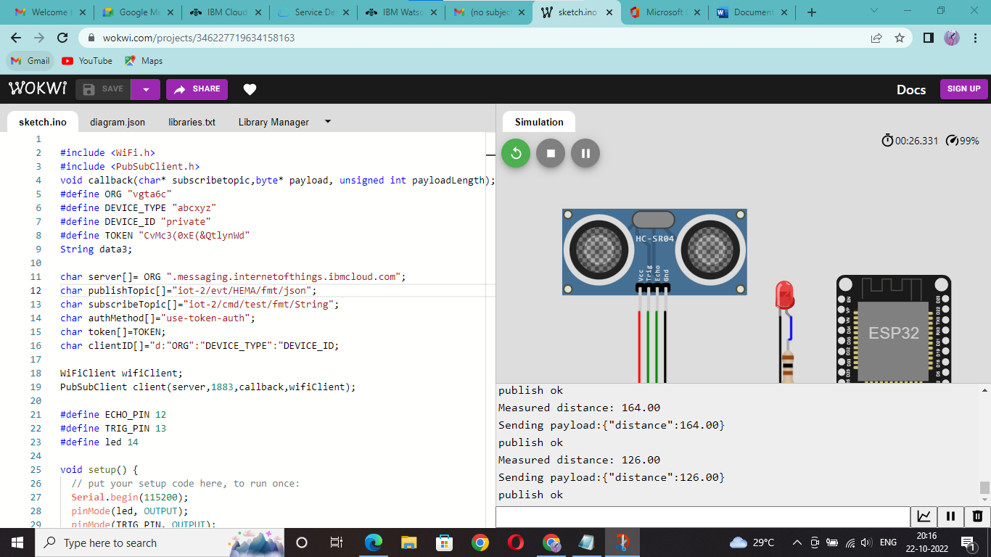

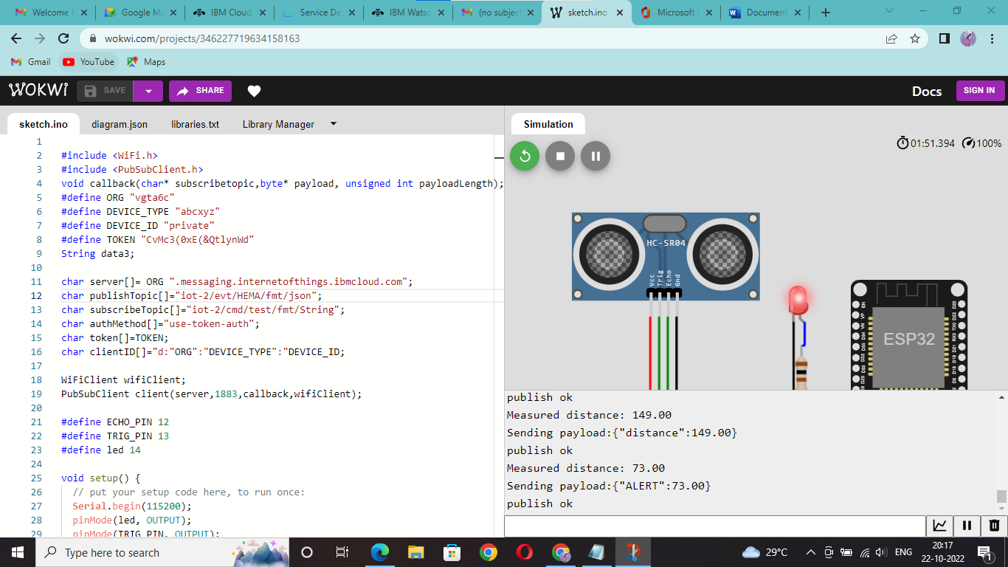

**IMAGES OF IBM CLOUD:**

